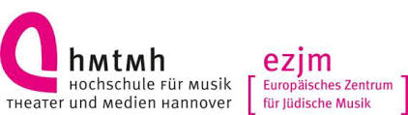
Magnified and Sanctified: The Music of Jewish Prayer II.
The 2nd International Conference on Jewish Liturgical Music
Hannover University of Music, Drama and Media, Germany
Hochschule für Musik, Theater und Medien Hannover
Neues Haus 1, 30175 Hannover, Germany
9-12 September 2019
Registration Form
Academic title, First name, Surname:
Institute:

Position:

Full address for correspondence:

Email address:

Mobile telephone number:
___________________________________________________________________________

Full 4-day Conference registration
I can only attend on the following day(s)
[ ] 9 September 2019 [ ] 11 September 2019
[ ] 10 September 2019 [ ] 12 September 2019
I have the following dietary requirements: …………………………………………..
I take part in the conference ‚banquet‘ on Tuesday 10 September: yes/no
I take part in the city tour on Wednesday 11 September afternoon: yes/no

Further information
Travel and accommodation are not included. Please make your own bookings. Bursaries may be available in case of need. Please send an email requesting a bursary together with the registration.

Please tell us how you first heard about the Conference: ………………………………………………………
Please fill in this Registration form and send by email as an attachment to: conference.ezjm@hmtm-hannover.de

